

**Name:** Fatima Malik

**Sap ID:** 40089

**Semester:** BSCS-6

**Course:** Computer Networks

**Lab 4**

**Solution 1:**

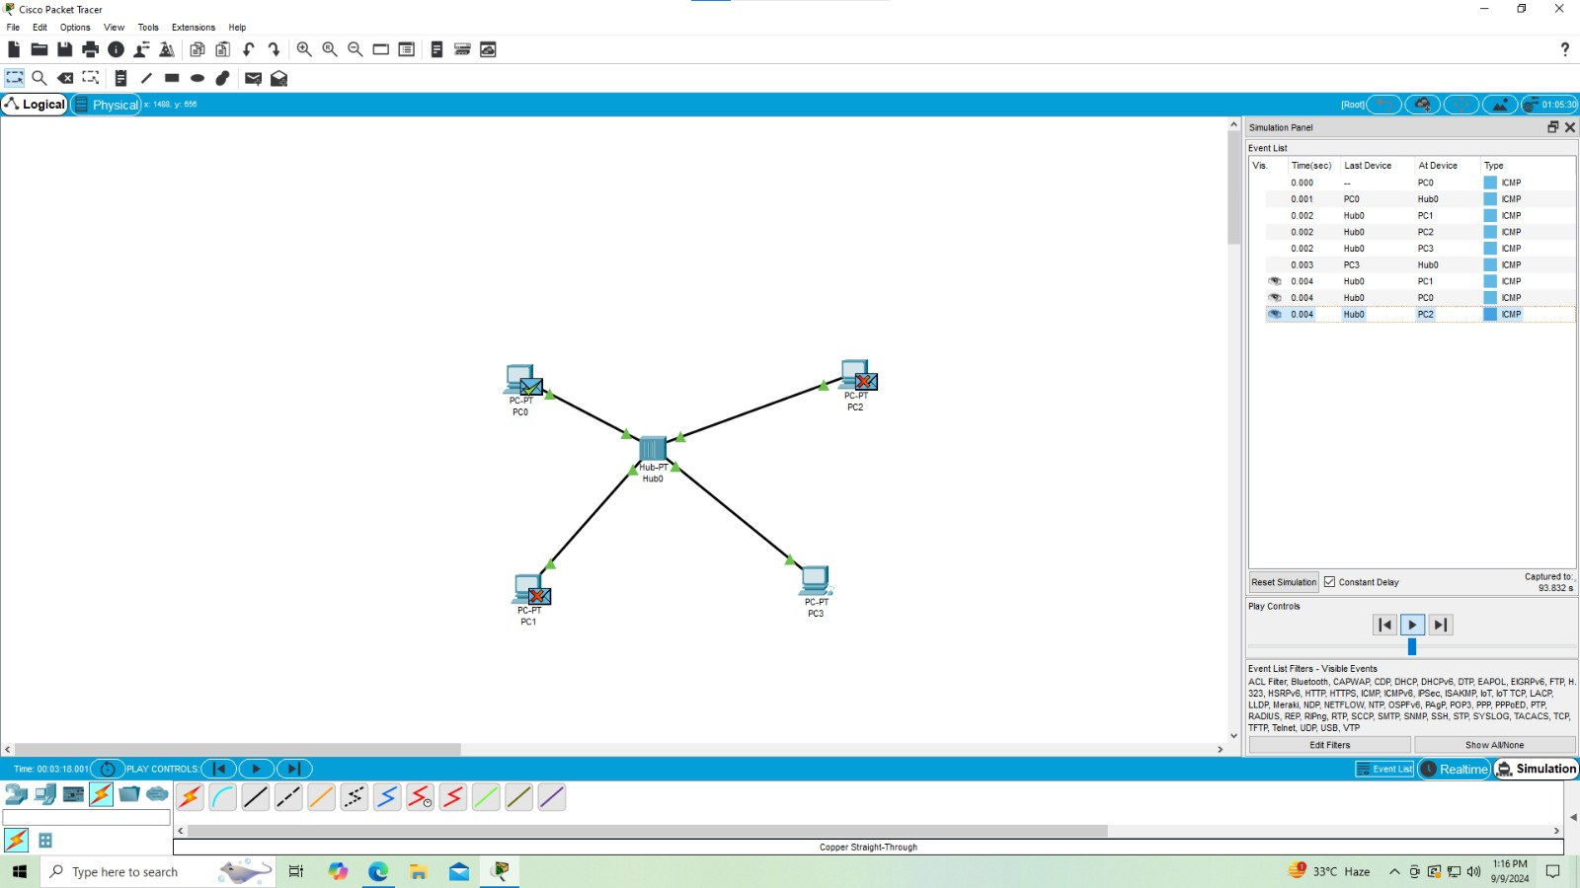

**Solution 2:**